Medical Device (Technical Innovation)
Contact person: LIN Hui | Email:369369@zju.edu.cn
Research background:
Research Alliance of Medical Device (Technical Innovation) is led by Sir Run Run Shaw Hospital affiliated to Zhejiang University School of Medicine and co-built by College of Computer Science and Technology, Department of Polymer Science and Engineering, School of Mechanical Engineering, College of Optical Science and Engineering, Institute of Translational Medicine, College of Biomedical Engineering and Instrument Science of Zhejiang University. It focuses on minimally invasive medicine research, clinical technology development and medical device development. Its main function is to provide theoretical support for the technological development of minimally invasive medicine, and to translate the innovative ideas in minimally invasive clinical practice into technical results. Through original innovation, integrated innovation, absorption of advanced foreign technology,thealliance continues to develop minimally invasive device and promote the localization of medical device.
Main research topics and progress:
1. Microminiaturized Three-dimensional High Definition Endoscopy Imaging: A double light path microelectronic endoscope with a diameter less than 9.8mm has been developed.A drive and signal processing circuit for high resolution CMOS image sensor hasbeen developed.The minimum CMOS image acquisition and LVDS processing module can be made.
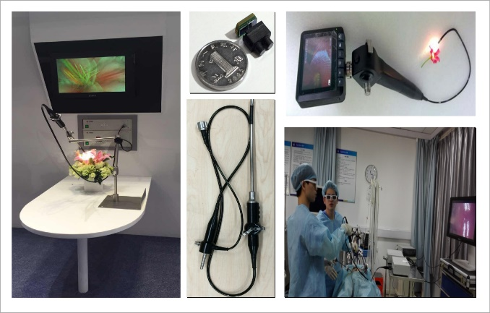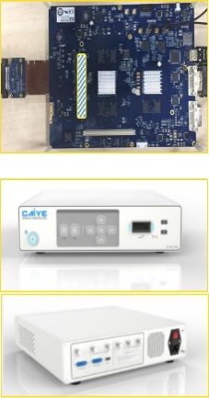
Fig. 1 Three-dimensional High Definition Endoscopy Imaging System
2. Cavity Viscera Anastomosis Stents: Based on the creation of seamless cavity viscera anastomosis stents technology system, biodegradable cavity viscera anastomosis stent has been developed. Clinical test of the stent started in 2017.
3. Additive Manufacturing of Organ Chips: The research results have been published in Journals of Biomaterials, Biofabrication, Microfluidics & Nanofluidics, Scientific Reports, etc. This research is supported by National Natural and Science Foundation of China.
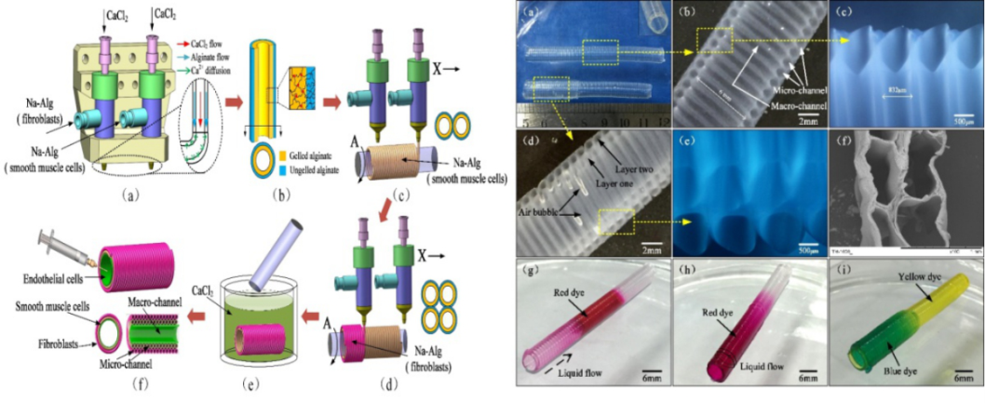
Fig. 2 Macro and Micro Secondary Structural Additive Manufacturing of Vascular Chips
4. Research and Application of Biological 3D Printer: 3D biologic printing technology with independent intellectual property rights has been developed. The research results have been published in Journals of ACS Applied Materials & Interfaces, Journal of Sol-Gel Science and Technology, Journal of the Acoustical Society of America, etc. This research is supported by the Key R&D Program of Zhejiang Province.
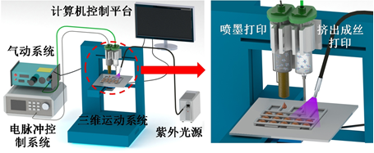
Fig. 3 Schematic Diagram of the Structure of Biological 3D Printer
5. Visualization of Medical Three-dimensional Volume Data: Researches on gradient estimation of colorful medical three-dimensional volume data, rending of multimodal/multivariable three-dimensional volume data fusion and view point selection of three-dimensional volume data have been carried out. The research results have been published in Journals of The Visual Computer, Computer Graphics Forum, etc.
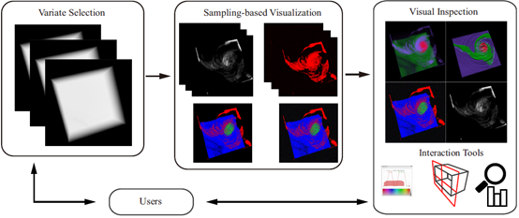
Fig.4 Flow Chart of Multivariable Three-dimensional VolumeData Fusion Based on Sampling
6. Low-dose CT and Quantification Technology: The iterative reconstruction algorithm for low-dose three-dimensional cone-beam CT has been developed. Combined with the shading correction method, the algorithm significantly improves the accuracy of the delineation of the target area for radiotherapy and reduced the radiation to healthy tissues. The feasibility study of radiomics using CBCT images in Stereotactic Body Radiation Therapy(SBRT) has been developed. The method can assist doctors in pathological diagnosis and improve the accuracy of radiotherapy and the survival rate of patients. The statistical based dual-energy multi-material decomposition method has been developed, which allows processing in image domain without accessing the projection data. It is highly practical, especially in the clinical application of fat-liver quantification.
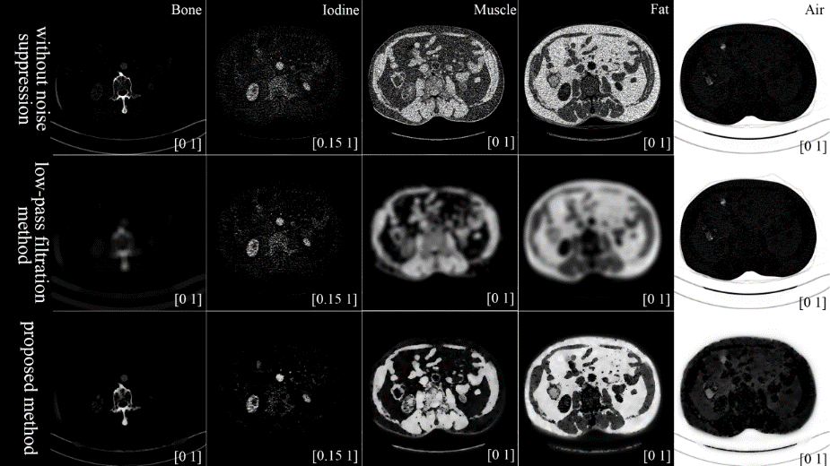
Fig. 5 Statistical Based Dual-energy Multi-material Decomposition Method
Member and college:
Project Leader: LIN Hui, Associate Chief Physician, Sir Run Run Shaw Hospital
Core Member: CAI Xiujun, Professor, Sir Run Run Shaw Hospital
YE Xuesong, Professor, College of Biomedical Engineering and Instrument Science
FU Jianzhong, Professor, School of Mechanical Engineering
LIN Hai, Professor, College of Computer Science and Technology
LIU Zhenyu, Professor, School of Mechanical Engineering
CAO Liping, Professor, Sir Run Run Shaw Hospital
LIANG Xiao, Chief Physician, Sir Run Run Shaw Hospital
LI Jianhua, Chief Physician, Sir Run Run Shaw Hospital
SUN Jihong, Chief Physician, Sir Run Run Shaw Hospital
NIU Tianye, Professor, Institute of Translational Medicine
LEI Yong, Professor, School of Mechanical Engineering
ZHANG Hong, Associate Professor, College of Biomedical Engineering and Instrument Science
SHEN Hongyao, Associate Professor, School of Mechanical Engineering
ZHENG Yinfei, Associate Professor, College of Biomedical Engineering and Instrument Science
LIU Jiquan Liu, Associate Professor, College of Biomedical Engineering and Instrument Science
TAO Yubo, Associate Professor, College of Computer Science and Technology
HU Weilin, Associate Chief Physician, Sir Run Run Shaw Hospital
WANG Peng, Associate Professor, College of Biomedical Engineering and Instrument Science
WANG Jing, Assistant Researcher, Sir Run Run Shaw Hospital
LIANG Yuelong, Attending Physician, Sir Run Run Shaw Hospital
Representative achievements:
1. Led by the Medical Device (Technical Innovation) Alliance of Zhejiang University, the intelligent diagnosis and treatment equipment manufacturing industry innovation center of Zhejiang Province has been formed. Meeting the demands of innovation and development of intelligent diagnosis and treatment equipment manufacturing industry, it focuses on the researches of premium medical image equipment, minimally invasive surgical device, new generation of in vitro diagnosis technology, biomedical materials and additive manufacturing technology, health monitoring and medical big data. It takes the key technology R & D, transfer &diffusion and first commercialization as the focal points, and aims to create a collaborative innovation ecosystem.

2. Supported by the Medical Device (Technical Innovation) Alliance of Zhejiang University, cognitive medical engineering technology research center of Zhejiang Province has been established. It is the first and unique provincial key laboratory focusing on medical artificial intelligence. It is committed to intelligent cloud hospital platform construction, heterogeneous medical system collaboration and safety management system, healthcare big data fusion and analysis, deep learning based clinical intelligence aided decision-making. It is going to promote the development and application of medical artificial intelligence.
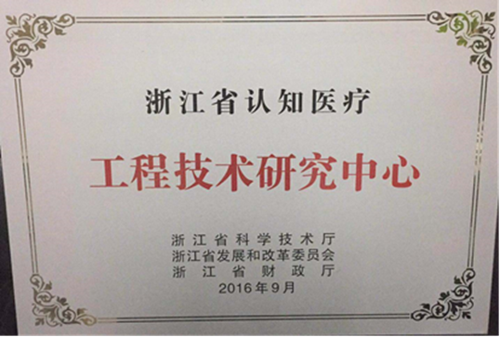
3. Wireless sleep apnea syndrome monitor obtained registration certificate for domestic class II medical device in April, 2017 (No. 20172210422). We have been issued production license since June, 2017. At present, the market sales amount hasachieved more than 4 million.
